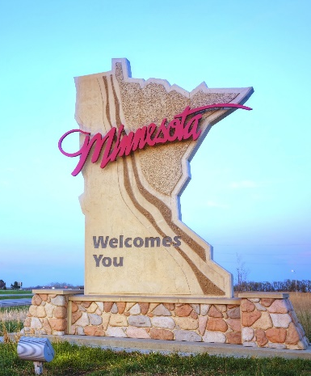
2022 MN TOUR
2022 MN Tour Participant Registration Form

Travel Destination: Twin Cities, MN
Grades: Completed 5-8
Cost: $50 / youth / experience
Registration Deadline: June 3, 2022
Capacity: 50 youth (first come/first serve) for each trip

Check the boxes for which experiences you plan to participate in.
June 16 – Minneapolis July 7 – St. Paul BOTH
U.S. Bank Stadium Service Project – Feed My Starving Children
MN Sculpture Garden Wabasha Street Caves
Minnehaha Falls St. Paul Gangster Tour
Midtown Global Market MN History Center

Use a separate form for each youth.

Name: Male Female

Club: Grade:

Address:

City: Zip:

Phone #: Email:

Parents Name:

Emergency Contact: Emergency Phone #:
I require an accommodation for a disability to participate in this program: Yes No
If your child has special dietary needs, please describe here to help your child have a more positive experience:
Make checks payable to: St. Croix County 4-H Leaders Association
Mail to: UWEX – St. Croix, 1960 8th Ave., Suite 140, Baldwin, WI 54002
Other Important Information
- Information on health forms, transportation, and schedule will be emailed to you after June 3, 2022.
- Financial assistance is available through the St. Croix County 4-H Leaders Association. Contact Heather to request assistance. heather.vierling@wisc.edu or 715-531-1938

