Bringing the Protective Factors Framework
to Life in Your Work

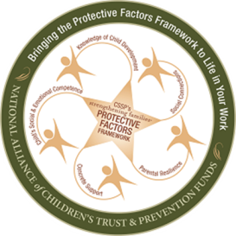
PROTECTIVE FACTORS FRAMEWORK
We have partnered with the Child Abuse and Neglect Prevention Board and the National Alliance of Children’s Trust and Prevention Funds to offer training to support the implementation of the Strengthening Families Protective Factors Framework. The content includes concrete examples
of everyday actions that research has shown to be effective in strengthening families, especially those who have experienced toxic stress and challenging life situations.

AUDIENCES
Fridays: April 13, May 11, June 1

9:00 a.m. - 1:00 p.m.

River Falls Public Library
140 Union St.
River Falls, WI 54022

No cost but registration is required one week in advance of each session.
(See below)

Early Childhood Educators
- Child Welfare Professionals
- Social Workers
- Healthcare & Mental Health
- Family Support Professionals

CORE CONTENT INCLUDES
- Six courses taught in three, 4-hour sessions
- May attend one, two or all three sessions
- Each workshop focuses on different Protective Factors

- Real-life parent stories that document the power of building protective factors
- A list of resources, references and websites to support each course

FOCUSED AROUND PROTECTIVE FACTORS
The training helps participants understand how the protective factors strengthen families

PARENTAL RESILIENCE
SOCIAL CONNECTIONS

KNOWLEDGE of PARENTING
AND CHILD DEVELOPMENT

CONCRETE SUPPORT IN TIMES
OF NEED

SOCIAL AND EMOTIONAL COMPETENCE OF
CHILDREN

To register, call the Pierce County UW-Extension Office at 715-273-6781

Facilitators are Javin Hintz, Parent Co-Presenter and Lori Zierl, UW-Extension Family Living Educator

Participants will receive certificate of attendance upon request

UW-Extension provides equal opportunities in employment and programming, including Title IX and ADA. To ensure equal access, please make requests for reasonable accommodations as soon as possible prior to the scheduled program service or activity. If you have questions, please call the UW-Extension office at 717-273-6781.

