Small Grassed Waterways Needed 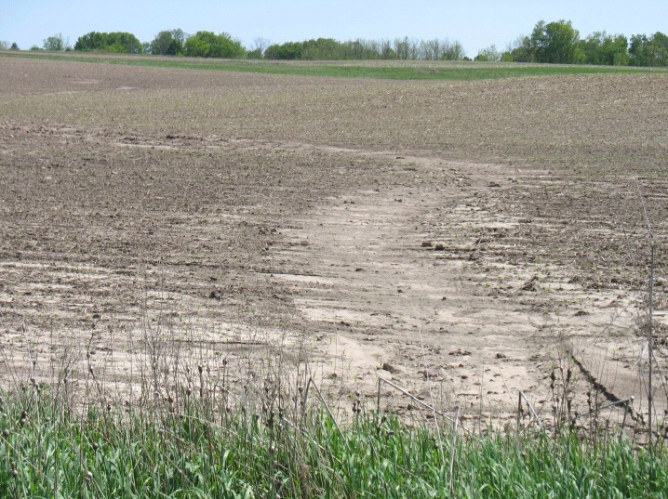
By Greg Andrews, Pierce County UW-Extension Agriculture Agent

Farmers and conservation officials are saying this spring has revealed the worst soil erosion in the last 30 years. For a number of reasons, severe sheet and rill and gully erosion has caused hundreds of thousands tons of topsoil loss throughout Pierce County. Public road maintenance trucks have been using snowplows and blades to remove topsoil off of area roads following recent downpours.
According to local conservation experts, the soil erosion is amplified by excessively-tilled farm fields leaving little or no crop residue and the increasing use of land-rolling equipment. In addition, the small grassed waterways that once were in farm fields where runoff concentrates and flow’s downslope have disappeared. Some growers removed the small grassed waterways by tilling and planting through these former soil saving small waterways.
Now is a prime opportunity for growers to identify the gully eroded areas of their fields where the concentrated runoff can be observed and put back or install small grassed waterways before they can no longer be seen as the corn and soybeans grow taller. These small grassed waterways once installed can protect future erosion and prevent harvesting equipment damage this upcoming fall.
Not to be confused with large grassed waterways, these small waterways can be easily installed by growers themselves. Identify the areas of concentrated flows in the fields (gullies), work adjacent soil in to the gullies, till the areas slightly and seed in a mix of grasses and legumes along with a cover crop such as oats. The Natural Resources Conservation Service (NRCS) recommends two different grass legume mixes for small grassed waterways. For livestock producers, NRCS recommends a mix of Smooth Bromegrass and Alfalfa. For cash crop farmers, NRCS recommends a mix of Smooth Bromegrass and Creeping Red Fescue. The Pierce County Land Conservation Department, NRCS and UW-Extension have copies of the small grassed waterway recommendations.
While small grassed waterways won’t solve all of the severe soil erosion problems observed, they are both soil saving and can save a lot of damage to harvesting equipment. For more information contact either Rod Webb and Mark Biel at 715-273-6763 or Greg Andrews at 715-273-6781.

